**Article ID:** 1147

**Article Name:** After Washing my clothes have grey marks on them

**Topic Location:** Laundry / Washing machine / Usage / Performance

**Meta-data:** stains, marks, detergent, dirt, clean

**Related Articles:**

**Related Questions:**

PNC

DIY

Safety

Link

Email

Book Engineer

Multimedia

Brand

**Article Content:**

Constant low temperature washing and the increasing use of liquid detergents (enzyme based) can cause mould and gelatinous dirt to build up in the door seal, pipes and drum. They can block up hoses, can cause a bad odour in the washing machine and may leave deposits on your laundry.

**Cause**

If you only do washes at 40°C or below, there will eventually be a build up of residues from detergent and dirt in the washing machine. This can cause grey stains on the laundry.

Stains on the clothes/fabrics can also be caused by a chemical reaction to certain personal care products or household products in combination with the detergent. These products could be things such as:

* Household bleach
* Acne cream
* Shampoo
* Perfumes
* Gels
* Hair Dye / Colour

**Solution**

The solution is to run a number of wash cycles at 90°C, without any laundry, but with a cup of sodium carbonate (Sodium carbonate irritates skin and mucous membranes. Please use it with extreme caution!) in the drum, to clean the seal and the washing machine internally.

Or you can use our special Electrolux cleaner for washing machines:

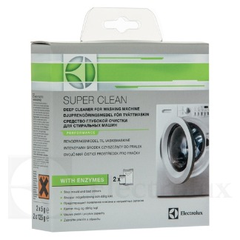

To buy this cleaner please follow the link to our webshop:

<http://shop.electrolux.co.uk/product/9029792786/Super-Clean+Washing+Machine+Cleaner>

**Prevention**

Marks/stains can be prevented by doing the following:

* Clean your washing machine on a regular base by using sodium carbonate (Sodium carbonate irritates skin and mucous membranes. Please use it with extreme caution!) or a special washing machine cleaner like <http://shop.electrolux.co.uk/product/9029792786/Super-Clean+Washing+Machine+Cleaner>
* Avoid future contact of your garments with the above mentioned personal care products or household products.
* Use a prewash. The prewash has to be done without detergent.
* Use the specific programme for the items being washed.
* Make sure that the correct amount of detergent is used. Use the amount that is recommended by the detergent manufacturer.